**BASEMENT REPORT**

* BASEMENT:
* A BASEMENT IS ONE OR MORE FLOORS OF BUILDING THAT ARE EITHER COMPLETELY OR PARTIALLY BELOW THE GROUND FLOOR.
* BASEMENT ARE TYPICALLY USED AS A UTILITY SPACE FOR A BUILDING WHICH IS USED TO PROVIDE ACCOMMODATION, STORAGE, CAR PARKING, SERVICES.
* THE MAJOR STRUCTURAL COMPONENTS OF A BASEMENT ARE THE WALL, THE FOOTING AND THE FLOOR.

SCHEMATIC REPRESENTATION OF BASEMENT

* PURPOSE OF BASEMENT:
* BASEMENT WALLS MUST BE DESIGNED TO RESIST LATERAL LOADS FROM THE SOIL AND VERTICAL LOADS FROM THE STRUCTURE ABOVE.
* IN CASE WHERE BASEMENT ARE ACTUALLY NEEDED FOR THEIR FUNCTION IN REDUCING NET BEARING PRESSURE THE ADDITIONAL FLOOR SPACE IN THE SUBSTRUCTURE IS AN ADDED BONUS.
* IN SOME CASES, BASEMENT MAY BE NEEDED FOR REDUCING NET BEARING PRESSURE BY THE REMOVAL OF THE SOIL.

* USE OF BASEMENT:
* AS PER THE GOVERNMENT RULE BASEMENT SPACES CANNOT BE ALLOWED FOR RESIDENTAIL PURPOSE.
* ACCORDING TO THE REGULATION OF THE NATIONAL BUILDING CODE OR BUILDING BY LAWS, A BASEMENT CAN BE USED ONLY AS A STORAGE , DARK ROOM, BANK CELLAR , PARKING SPACE OR TO KEEP EQUIPMENT REQUIRED CONSTANT AIR CONDITIONING.
* ACCOURDING TO THE BUILDING BY LAWS, KITCHEN, BATHROOM AND TOILET ARE ALSO NOT ALLOWED IN A BASEMENT, UNLESS THE SEWER LEVELS PERMIT THE SAME AND THERE IS NO CHANCE OF BACK FLOW AND FLOODING OF THE SEWERAGE.
* FOR COMMERICAL PURPOSE THE GOVERNMENT ALLOWS YOU TO BUILD OFFICES IN BASEMENTS. HOWEVER THE SPACE WILL BE INCLUDED IN THE CALCULATION OF FAR USAGE IN THIS CASE.
* FOR GROUP HOUSING BASEMENT CONSTRUCTION IS ALLOWED FOR PARKING, UTILITIES AND SERVICES AND IS NOT COUNTED IN FAR THUS. THE CONCEPT OF BASEMENT PARKING IS NOW GETTING POPULAR IN HOUSING PROJECT.
* GRADE OF BASEMENT:

|  |  |  |  |
| --- | --- | --- | --- |
| GRADE | POSSIBLE USE | CONDITION REQUIRED | MOISTURE EXCLUSION |
| GRADE 1: BASIC UTILITY | CAR PARKING, MECHANICAL PLANT ROOM, ETC | >65% RELATIVE HUMIDITY 15-32˚C TEMPERATURE. | MINOR WET SEEPAGE AND VISIBLE DAMP PATCHES MAY BE ACCEPTABLE. |
| GRADE 2:  BETTER UTILITY | RETAIL STORAGE, ELECTRICAL PLANT ROOMS | 35-50% RELATIVE HUMIDITY TEMPERATURE DEPENDS ON USE : <15˚C FOR STORAGE, UP TO 42˚C FOR PLANT ROOMS. | WET SEEPAGE UNACCEPTABLE. NO VISIBLE MOISTURE PATCHES. |
| GRADE 3:  HABITABLE | OFFICES, RESIDENTIAL USE, KITCHENS, RESTAURANTS, ETC | 40-60% RELATIVE HUMIDITY TEMPERATURE RANGE 18-29˚C, DEPENDING ON USE. | SEEPAGE AND WET PATCHES UNACCEPTABLE. POSSIBLE ACTIVE CONTROL OF INTERNAL ENVIRONMENT REQUIRED ENVIRONMENT REQUIRED TO CONTROL TEMPERATURE AND HUMIDITY. |
| GRADE 4:  SPECIAL | ARCHIVE STORAGE OF BOOKS, DOCUMENTS, ART, ETC | 35-50% RELATIVE HUMIDITY TEMPERATURE RANGE TYPICALLY 13-22˚C | ENVIRONMENT TIGHTLY CONTROLLED BY ACTIVE MEASURES. SEEPAGE AND VISIBLE DAMPNESS UNACCEPTANCE. |

* ADVANTAGES OF BASEMENT:

1. ADDITIONAL STORAGE SPACES
2. BETTER UTILISATION OF LAND
3. OFFERS SEASONAL COMFORT
4. MULTIPURPOSE SPACE
5. PERFECT AS AN EMERGENCY SHELTER
6. EASY ACCESS FOR UNDERGROUND REPAIRS

* DISADVANTAGES OF BASEMENT:

1. ADDITIONAL CONSTRUCTION COST
2. DAMP AND MOSISTURE CONCERNS
3. DANGERS OF FLOODING
4. REQUIRES PROFESSIONAL FOR CONSTRUCTION
5. INCONVENIENT ACCESS ROUTES FOR FURNTTURES

* TYPES OF BASEMENT:

ALL EXCAVATION OPERATORS MOST KNOW THE LINE THE FINAL DEPTH OF THE EXCAVATION, THE APPOXIMATE WIDTH OF THE EXCAVATION AT THE TOP AND THE LOCATION OF ANY SERVICES OR OTHER HAZARDS A) BOTTOM UP EXCAVATION

1. **OPEN CUT**

* IF THERE IS SUFFICIENT RIGHT OF WAY OPEN CUT TRENCHES CAN BE USED IN ALMOST ANY SOIL CONDITION.
* GENERALLY A SLOPE OPEN CUT EXCAVATION IS THE MOST COST AND SCHEDULE EFFECTIVE METHOD OF TEA TRENCHING
* WHEN THE TRENCH IS VERY DEEP AND EXPENSIVE BACKFILL MATERIALS ARE REQUIRED THEN VERTICAL CUT AT THE TOE OF THE SLOPE SUPPORTED BY SHORING OR FLATTENING OF EXCAVATION SLOPES.

**ADVANTAGES:**

* ALLOWS CONTINOUS EXCAVATION , LAYING AND BACKFILLING OPERATION
* MINOR BREAKDOWN USUALLY DO NOT CAUSES DELAYS TO ALL ACTIVITES
* THE OPEN TRENCH NEEDS ONLY THE DESIGN OF THE CUT BANK SLOPE.GUIDELINES CAN BE USED ALTHOUGH COST SAVING USUALLY WILL RESULT IF THE BANK SLOPE IS CHECKED AND DESIGNED BY A REGISTERED ENGINEER FOR STEEDER SLOPE SLOPING THE EXCAVATION IS THE SIMPLEST METHOD AND RUNNING SANDS
* OPEN CUT METHOD IS SUITABLE FOR MOST GROUND CONDITION EXCEPT FOR OOZING MUD AND RUNNING SAND
* THE OPEN TRENCH PROVIDES EASY ACCESS TO THE WORK BEACAUSE EQUIPMENT AND CONSTRUCTION MATERIALS ARE MINIMIZED
* THE SLOPE OF THE BANK REQUIRES MORE EXCAVATION AND BACKFILL VOLAUME THAN THE OTHER OPTIONS.

**DISADVANTAGES:**

* THE ONLY BANK SUPPORT IS THE STRENGTH OF THE SOIL.IF DRYING, FLOODING OR CHANG OF SOIL PROPERTIES WEAKNENS THE SOIL, THEN SLOUGHING AND COLLAPSE CAN HAPPEN WITH LITTLE OR WORK AREA
* THE SLOPED BANKS REQUIRES A WIDER WORK AREA
* THE BANK SLOPE MAY FORCE THE USE OF LARGER EQUIPMENT BEACAUSE THE DISTANCE TO REACH INTO THE TRENCH IS INCREASED AND GREATER VOLUMN OF SOIL MUST BE EXCAVATION AND BACKFILLED.

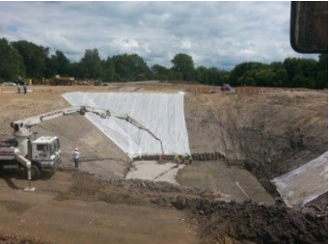

1. **BOTTOM UP EXCAVATION:**

* THIS CONVENTIONAL METHOD INVOLVES FIRST SINKING TEMPORARY DIAPHRAGM WALLS TO THE REQUIRED DEPTH BELOW GROUND, DIGGING AND REMOVING SOIL, INSTALLING TEMPORARY STEEL STRUTTING AND THEN CREATING THE COMPLETE HOLE WITH A CONCRETE SLAB BASE AND OPEN TO THE SKY.
* FORM PERIMETER WALLS TO ENCLOSE THE AREA TO BE EXCAVATED.
* PROCEED UPPER WORKS: EXTENDED COLUMN, CONTINUE UPPER SLABS TOWARDS GROUND LEVEL.
* EXCAVATION->INSTALL PROPS->CONSTRUCTION OF FOUNDATION + COLUMNS->SLAB (SUSPENDED SLAB)

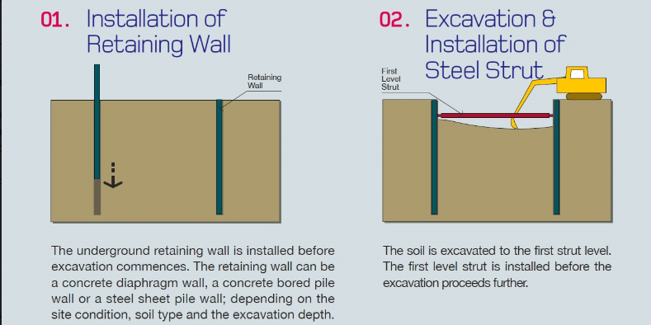

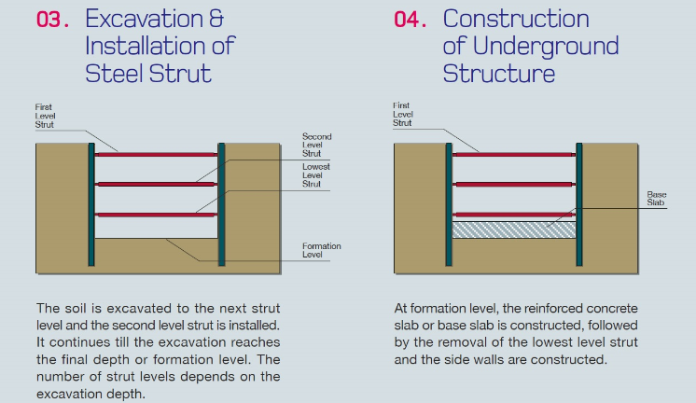

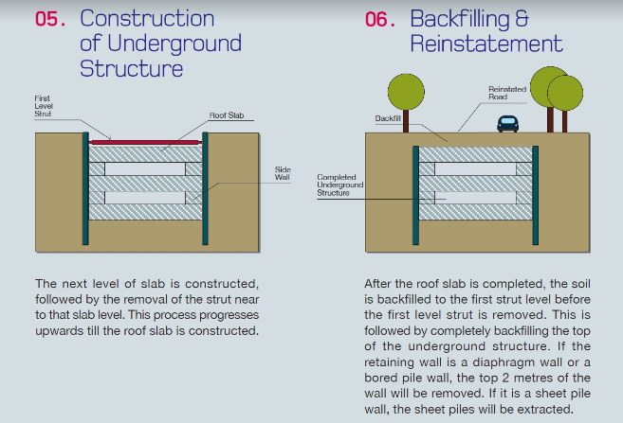

1. **TOP DOWN EXCAVATION:**

* FORMATION OF PERMANENT RETAINING WALSS TO THE PERIMETER OF BASEMENT AREA
* FROM INTERNAL FOUNDATION AND COLUMN SUPPORT BY USING PLUNGE METHOD
* CREATE THE UPPERMOST FLOOR SLAB
* EXCAVATE DOWNWARDS OPENING ON SLAB OR SERVICES SHAFTS
* REMOVE TEMP BASE, EXCAVATE UNTIL THE DEPTH OF NEXT FLOOR LEVEL
* CAST THE NEXT FLOOR LEVEL, REPEAT THE PROCESS.
* CAN USE NON SUSPENDED SLAB FOR THE BASEMENT SLAB.
* 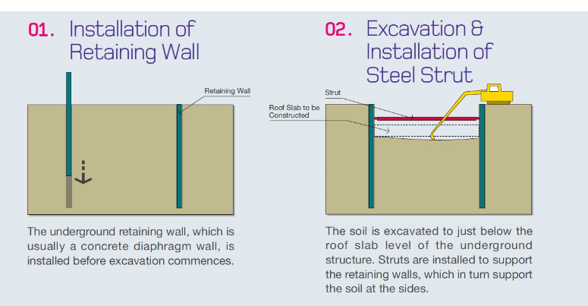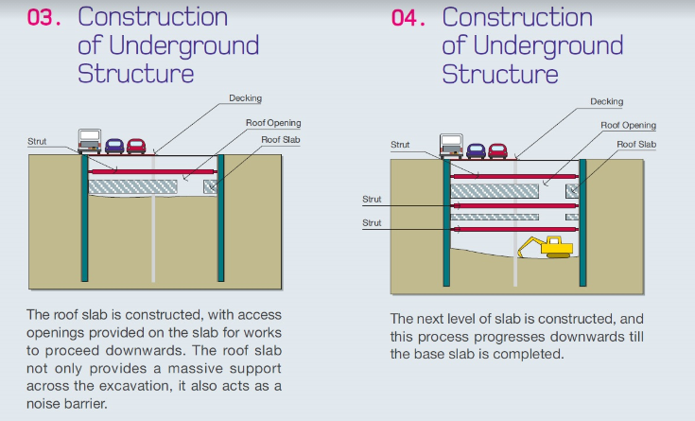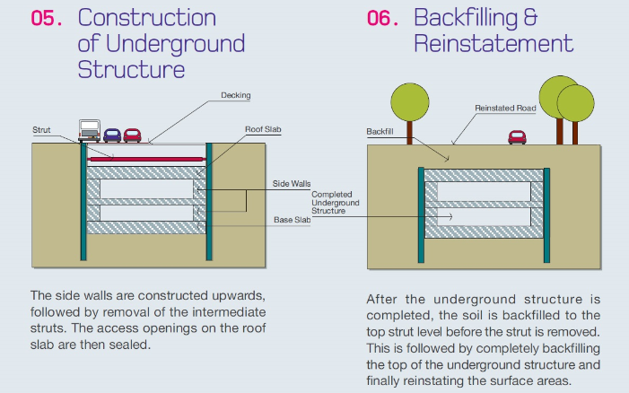
* TYPES OF WATERPROOFING:

BASEMENT WATER PROOFING INVOLVES TECHNIQUE AND MATERIALS USED TO PREVENT WATER FROM PENETRATING THE BASEMENT OF HOUSE OR BUILDING.

TYPE A TYPE B TYPE C

(BARRIER PROTECTION (STRUCTURALLY ( DRAINED

TANKED) INTEGRAL PROTECTION) PROTECTION)

1. **TYPE A ( BARRIER / TANKED PROTECTION)**

* USE IMPERVIOUS MATERIAL INTERNALLY OR EXTERNALLY TP EXCLUDE MOISTURE
* THE SELECTED WATERPROOFING ELEMENT MUST BE CAPABLE TO WITHSTAND HYDROSTATIC PRESSURE FROM GROUND WATER & OTHER LOADING
* CREATE A TANKING EFFECTS
* THE OBJECTIVE OF TANKING IS TO PROVIDE A CONTIOUS WATERPROOF MEMBRANE WHICH IS APPLIED TO THE BASE SLAB AND WALLS WITH COMPLETE CONTINUITY BETWEEN THE TWO APPLICATIONS
* THE TANKING CAN BE APPLIED EXTERNALLY OR INTERNALLY
* ALTERNATIVES TO MASTIC ASPHALT ARE POLYTHENE SHEETING BITUMINOUS COMPOUNDS EPOXY & RESINCOMPOUNDS AND BITUMEN LAMINATES

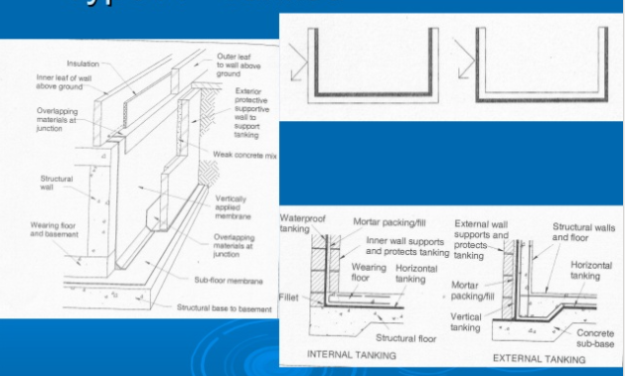

1. **TYPE B ( STRUCTURALLY INTERNAL SYSTEM )**

* STRUCTUREAL INTERAL PROTECTION REINFORCED OR PRESTRESSED CONCRETE DESIGNED THROUGH COMPOSITE AND INTERATED DETAILS SUCH AS WATER BARS TO BE WATER RESISTANT
* Type B Protection relies heavily on the design and materials incorporated into the external shell of the structure.
* Design, materials, as well as the quality of the workmanship contribute to the success of Type B Systems.
* The pattern of any seepage encountered is often associated with poor joints, cracks or other discontinuities such as service penetrations.

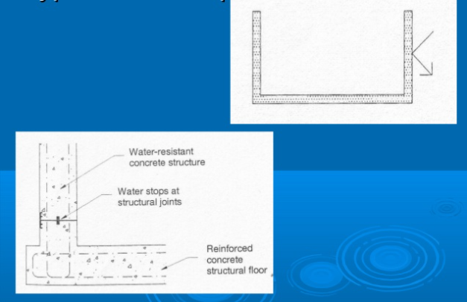

1. **TYPE C ( DRAINED PROCTECTION ) SYSTEM**

* THE BASIC CONCEPT IS VERY SIMPLE. IT ACCEPT THAT A SMALL AMOUNT OF WATER SEEPAGE IS POSSIBLE THROUGH A MONOLITHIC CONCRETE WALL AND THE BEST METHOD OF DEALING WITH SUCH MOISTURE IS TO COLLECT IT AND DRAIN IT AWAY
* ANY WATER SEEPING THROUGH EXTERNAL WALL AND FLOOR IS DRAINED TO A SUMP VIA AN INTERNAL CAVITY TYPICALLY CREATED BY PROPRIETARY CAVITY SYSTEM AND PUMPED OR DRAINED AWAY

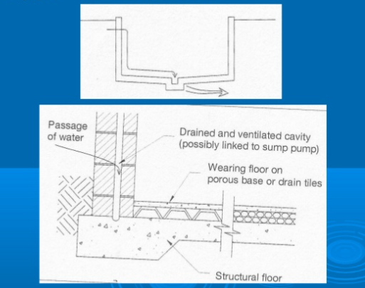

* BASEMENT VENTILATION:

1. **NATURAL VENTILATION METHOD:**

* NATURAL VENTILATION MAKES USE OF NATURAL AIR CURRENTS, BUT THIS TYPE OF VENTILATION WORKS ONLY FOR BASEMENTS WITH WINDOW THAT ARE STATEGICALLY PLACED AND ARE TO OPEN AND CLOSED
* WHILE THE NATURAL METHOD CONSERVES ENERGY IT DOES REQUIRE MORE WORK
* WINDOW MUST BE OPEN AT REGULAR INTERUALS AND CLOSED DURING TIMES OF RAINFALL OR AT NIGHT TO PREVENT INTRUDERS FROM ENTERING THE BASEMENT
* WINDOW SHOULD BE OPPOSITE EACH OTHER ACROSS THE BASEMENT SPACE FOLLOWING THE NATURAL DRAFT OF THE BASEMENT.

1. **MECHANICAL VENTILATION METHOD:**

* MECHANICAL VENTILATION USES FANS & VENTS TO EXHAUST EXISTING BASEMENT AIR AND BRING IN FRESH OUTDOOR AIR
* THIS TYPE OF SYSTEM MAY BE AS SIMPLE AS PLAYING SMALL WINDOWS OR AS TECHICAL AS INSTALLING AN EXHAUST FAN WITH VENTILATION PIPE

**AXIAL FANS:**

* AXIAL FANS ARE NAMED FOR THE DIRECTION OF THE AIRFLOW THEY CREATE
* BLADES ROTATING AROUND AN AXIS DRAW AIR IN PARALLEL TO THAT AXIS AND FORCE AIR OUT IN SAME DIRECTION
* AXIAL FANS CREATE AIRFLOW WITH A HIGH RATE MEANING THEY CREATE A LARGE VOLUME OF AIRFLOW HOWEVER THE AIRFLOW THEY CREATE ARE OF LOW PRESSURE.

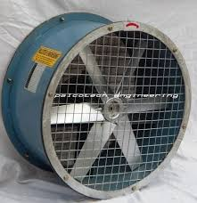

**CENTERIFUGAL FANS:**

* THE CENTRIFUGAL FANS OFFTEN CALLED BLOWERS
* THE PRESSURE OF AN INCOMING AIRSTREAM IS INCREASED BY A FAN WHEEL, A SERIES OF BLAADES MOUNTED ON A CIRCULAR HUB CENTRIFUGAL FAN MOVE AIR RADIALLY. THE DIRECTED THROUGH A SYSTEM OF DUCTS OR TUBES
* THE AIRFLOW CREATE BY CENTRIFUGAL FANS IS DIRECTED THROUGH A SYSTEM OF DUCTS OR TUBES. THIS HEPLS CREATE A HIGHER PRESSURE AIRFLOW THAN AXIAL FANS
* DESPITE A LOWER FLOW RATE, CENTRIFUGAL FANS CREATE A STEADIER FLOW OF AIR THAN AXIAL FANS.

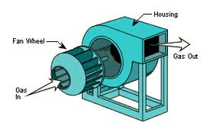

* TYPES OF CONTRUCTION:
* RAFT FOUNDATION :- THIS IS THE GENERAL FORMAT FOR BASEMENT CONSTRUCTION AND CONSISTS OF A SLAB RAFT FOUNDATION WHIVH FORMS THE BASEMENT FLOOR AND HELPS TO DISTRIBUTE THE STRUCTURAL LOADS TRANSMITTED DOWN THE RETANING WALLS
* RETAINING WALL :-
* A RETANING WALL IS A STRUCTURE DESIGNED AND CONSTRUCTED TO RESIST THE LATERAL PRESSURE OF SOIL WHEN THERE IS A DESIRED CHANGED IN GROUND ELEVATION THAT EXCEED THE ANGLE OF REPOSE OF THE SOIL
* A BASEMENT WALL IS ONE KIND OF RETAINING WALL
* RETAINING WALL AND PERIPHERAL WALLS TO BASEMENTS ARE SUBJECT TO LATERAL PRESSURE FROM RETAINED EARTH LIQUIDS OR A COMBINATION OF SOIL AND WATER
* THEY ARE NORMALLY MADE IN STRUCTURAL WORK OF CONCRETE OR BRICK
* THE WALLS ARE BASICALLY VERTICAL CANTILEVER EITHER FREE OR PRODPED
* THE WALLS MAY BE ACTING AS PURE CANTILEVER PRODPED CANTILEVER TIED CANTILEVER SIMPLY SUPPORTED OR CONTINOUS SPANNING SLAB ETC.
* THEY MAY BE STIFFEND BY SHAPING INTO FINS COUNTERFORTS, DIAPHRAGRAM, ZIG-ZIG, AND MANY ORTHER PROFILES
* THEY CAN BE MASS FILLED RENIFORCED OR POST TENSIONED
* RAFT FOUNDATION
* RAFT FOUNDATION ARE FORMED BY REINFORCED CONCERET SLABS OF UNIFORM THICKNESS THAT COUER A WIDE AREA OFTEN THE ENTIRE FOOTPRINT OF A BUILDING
* THEY SPREAD THE LOAD IMPOSE BY A NUMBER OF COLUMNS OR WALLS OVER THE AREA OF FOUNDATION AND CAN BE CONSIDERED TO FLOAT ON THE GROUND AS RAFT FLOATS ON WATER
* WHEN THE GENERAL SOIL IS HAVING THE LOW VALUE OF BEARING CAPACITY LIKE SOFT CLAY MADE UP GROUND SANDY SOIL OR UNCERTAIN BEHAVIOUR DUE TO SUBSOIL WEAK CONDITION
* IN SUCH CASE THE PILE FOUNDATION OR INDEPENDENT COLUMN BECOME DIFFICULT AND UNECONOMICAL THEREFORE THE FOUNDATION OF THE STRUCTURE IS SPREAD FOR THE ENTIRE AREA OF THE BOTTOM OF THE STRUCTURE LIKE OF A FLOOR
* RAFT FOUNDATION CONSIST OF THICK REINFORCEMENT CONCRETE SLAB COVERING THE SAID AREA OF THE FLOOR
* THE SLAB IS REINFORCED WITH BARS RUNNING IN RIGHT ANGEL TO EACH OTHER BOTH NEAR BOTTOM AND TOP FACE OF THE SLAB
* SUITABLE WHERE:
* FLOOR IS SMALL AND STRUCTURAL LOADING ARE LOW SUCH AS IN ONE OR TWO STOREY DOMESTIC CONSTRUCTION.
* A BASEMENT IS REQUIRED
* GROUND CONDITION ARE POOR
* WHERE IT MAY BE IMPRATICAL TO CREATE INDIVIDUAL STRIP FOUNDATION FOR A LARGE NUMBEROF INDIVIDUAL LOAD. IN GERNRAL TERMS IF STRIP OR PAD FOUNDATION WOULD COVER 50% OR MORE OF THE FLOOR AREA THEN A RAFT MAY BE MORE APPROPRIATE.
* TYPES OF RAFT FOUNDATION:

1. **SLAB TYPE**
2. **SLAB AND BEAM TYPE**
3. **CELLULAR TYPE**
4. **SLAB TYPE:**

* THIS IS THE SIMPLEST FORM OF RAFT FOUNDATION
* RENIFORCEMENT IN THIS SLAB TYPE FOUNDATION IS PLACED IN BOTH DIRECTION & MORE REINFORCEMENT IS REQUIRED AT THE COLUMN LOCATION AND LOAD BEARING WALLS.
* MAT IS USED WHEN THE COLUMN & WALLS ARE UNIFORMALLY SPACED AT SMALL INTERVAL AND THE SUBJECTED.

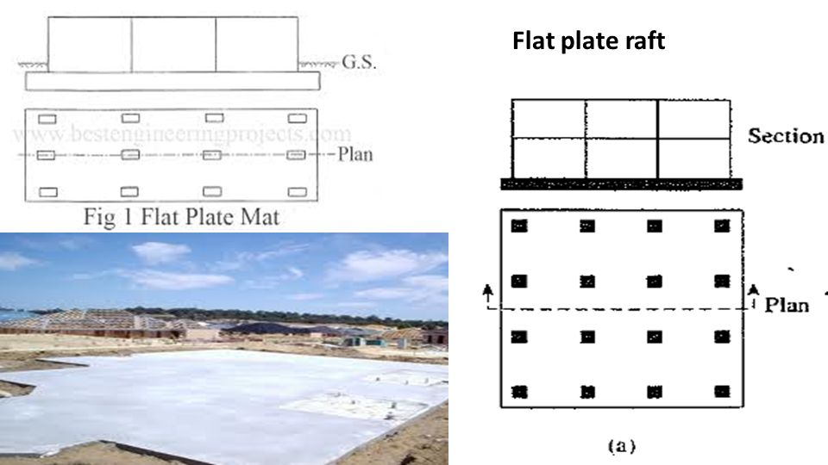

1. **SLAB AND BEAM TYPE:**

* BEAM ARE LAID IN PERPENDICULAR DIRECTION AND ALL OF THESE BEAMS CONNECTED BY RAFT SLAB
* COLUMNS ARE SUITUTED EXACTLY ON INTERSECTION OF BEAMS OF RAFT FOUNDATION
* THIS TYPE RAFT FOUNDATION IS SUITABLE WHEN THE COLUMN IS CARRYING UNEQUAL LOAD AND THERE IS LARGE SPACE BETWEEN THEM.
* AS A FOUNDATION TO SUPPORT THE HEAVIER LOADS OF WALSS OR COLUMN A SOILD SLAB RAFT WOULD REQUIRE CONSIDERABLE THICKNESS.
* THIS RAFT CONSISTS OF UPSTAND OR DOWN STAND BEAMS THAT TAKE THE LOAD OF WALLS OR COLUMNS AND SPREAD SLAB WHICH BEARS ON NATURAL SUBSOIL.

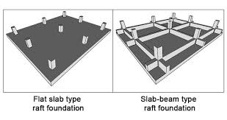

1. **CELLULAR TYPE:**

* CELLULAR RAFT FOUNDATION IS ALSO KNOWN AS BOX TYPE RAFT FOUNDATION OR RIGID FRAMS. RAFT FOUNDATION WHERE BOXES LIKE STRUCTURE ARE FORMED WHERE THE WALSS OF EACH BOX ACTS AS BEAM AND THESE ARE CONNECTED BY SLAB AT TOP AND BOTTOM
* HERE TWO CONCERTE SLAB ARE PLACED ONE ON TOP AND ANOTHER AND CONNECTED WITH FOUNDATION WALSS IN BOTH DIRECTION & THUS FORMS A CELLULAR RAFT FOUNDATION
* THE BEAMS AND SLAB ARE UNITED IN SUCH A WAY THAT THEIR CROSS SECTION LOOK LIKE I-SECTION. THIS TYPE OF FOUNDATION CANS RESISTS VERY HIGH BENDING STRESSES AND SUITABLE FOR LOOSE SOIL WHERE SETTELMENT IS UNEVEN.

